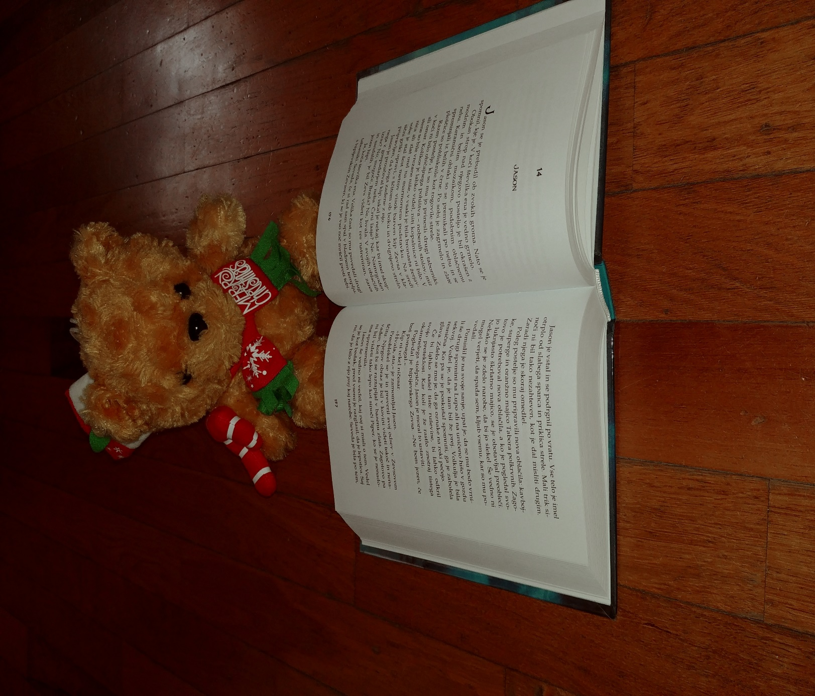
Nik is reading a book.

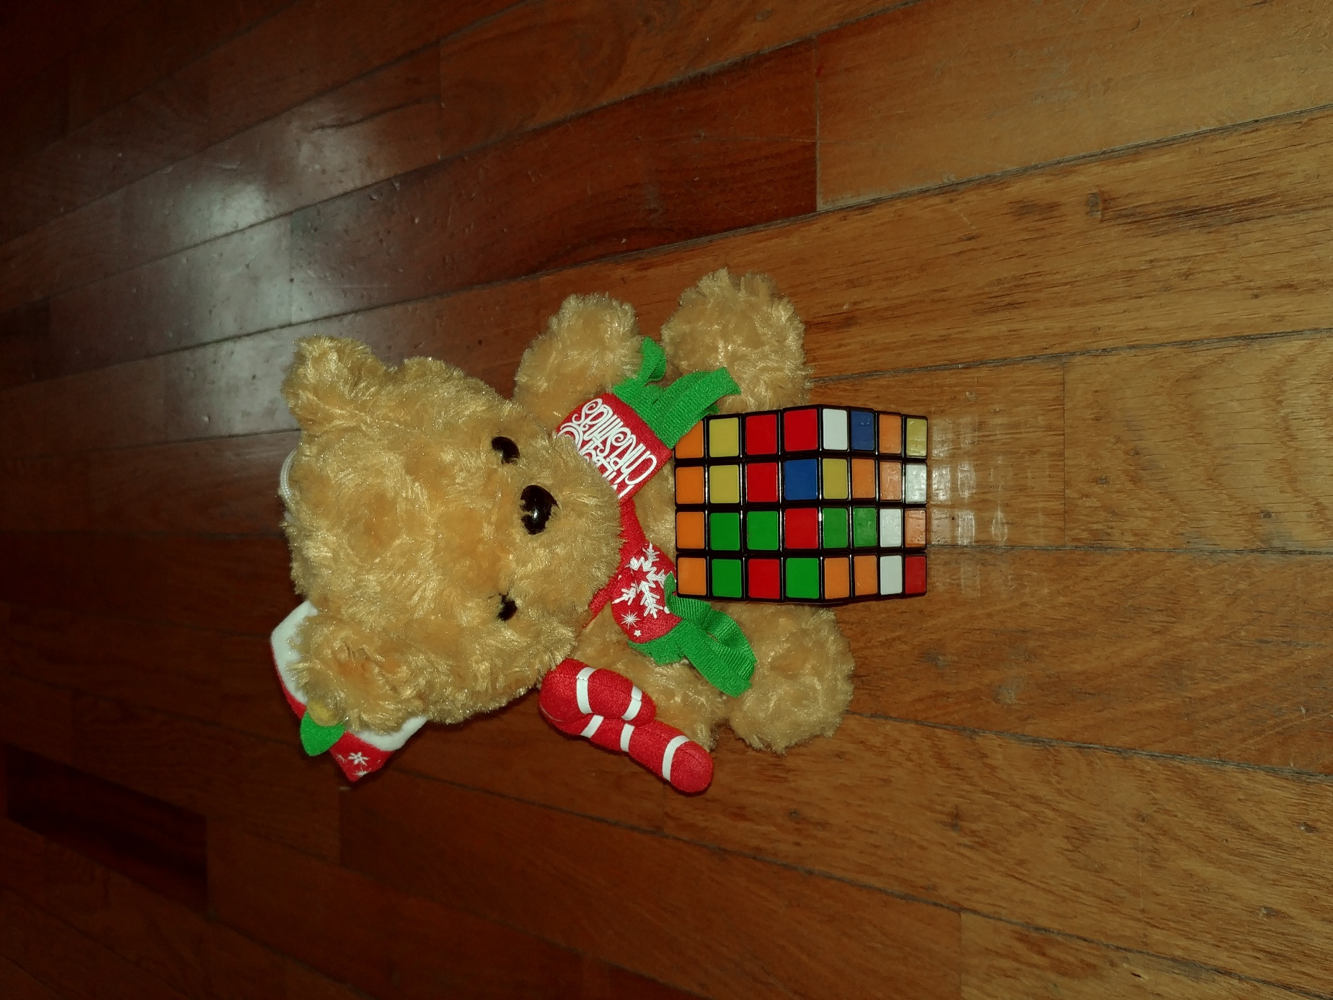
Can Nik solve rubik's cube 4x4x4x4?

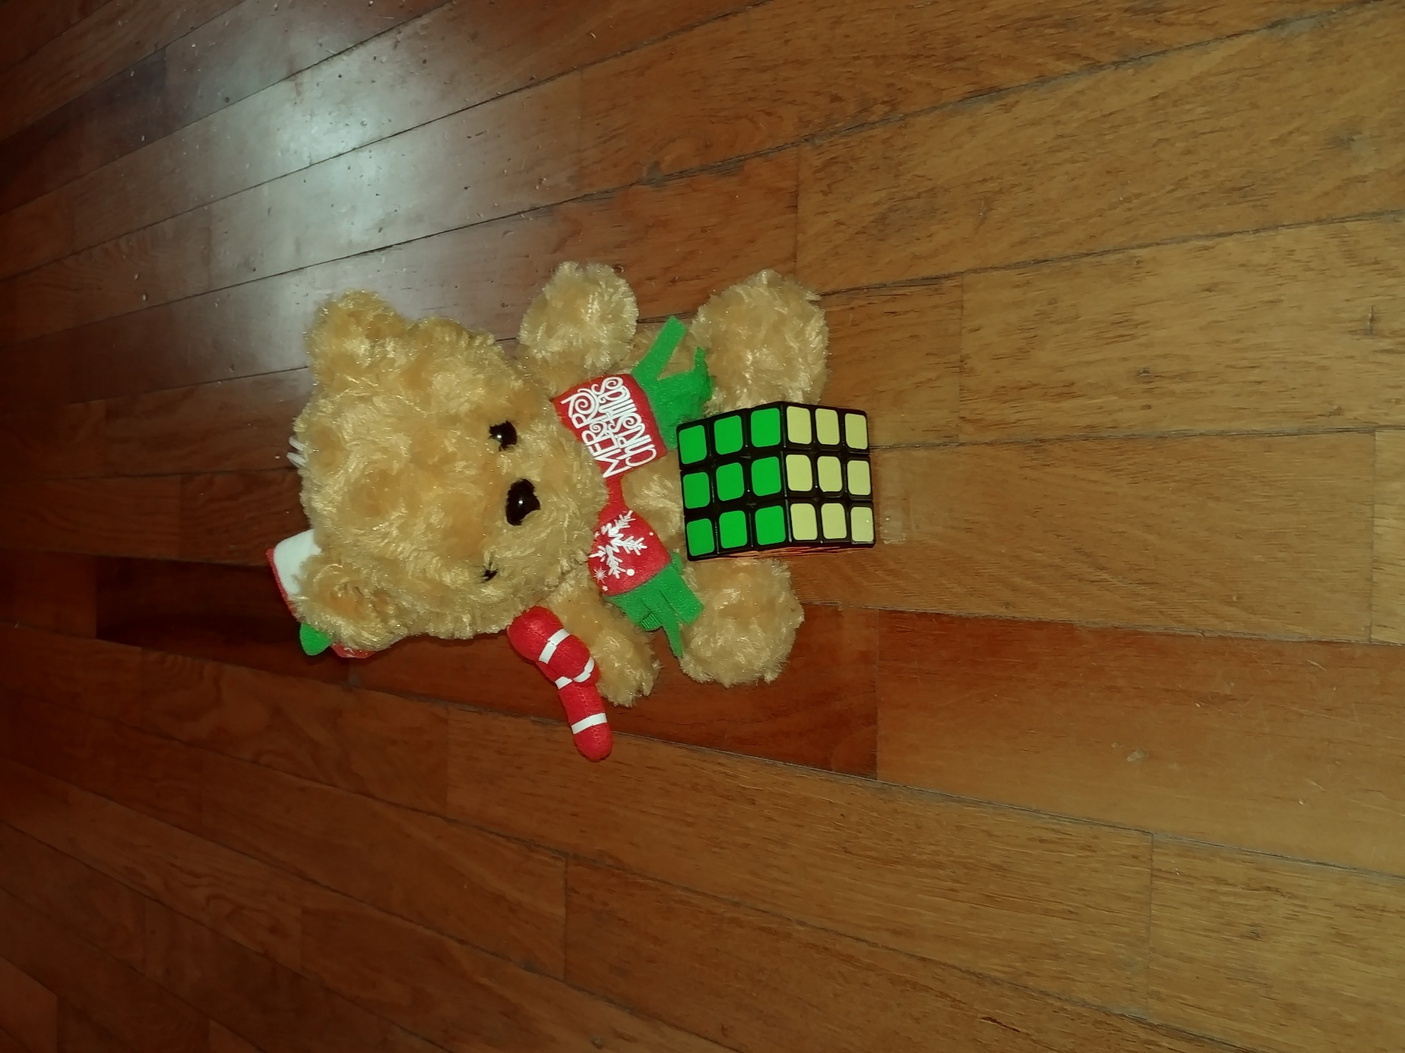
He solved the rubik's cube 3x3x3.

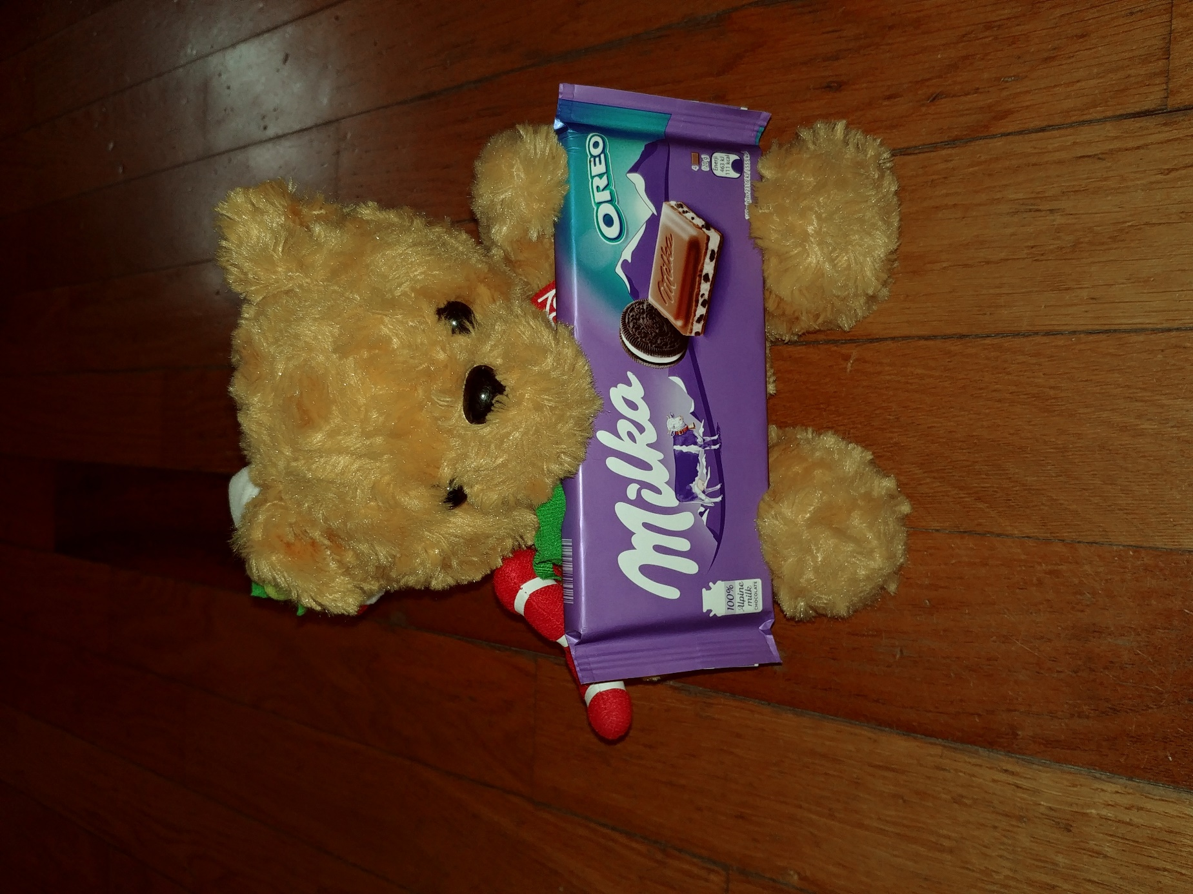
Nik is eating chocolate.

